Welcome to 3rd Grade!
Hello, I'm Mrs. Frarie and I cannot wait to meet you! I hope you’ve had a fun summer.
We’re going to learn so much this year! Native Americans, states, multiplication facts, whales, and famous women are just a few of the topics we’ll focus on.

This letter contains your school supply list as well as a fun getting to know you activity to work on.
For our getting to know you activity I want you to "bag" yourself! I will attach the directions, but basically you will put a number of items in a bag and bring it to school on the first day. We will then share out and learn more about one another!
Here are the supplies you will need for the beginning of the year:
* lots of quality sharpened pencils (not mechanical)
* lots of pencil top erasers
* one 1 or 1 ½ inch binder
* sturdy homework pocket folder with holes to put in your binder
* 2-3 Expo markers (low odor)
* water bottle with pop top (no screw tops),
* old clean sock for erasing white boards
*correcting pen in red or green
Optional: crayons/colored pencils, lined paper to keep at home, deck of cards for math games at home

Donations for the class: soft tissues, sealable baggies in quart size
If you lose this list, it’ll be on my website.
IMPORTANT: Attached is your first fun project. You have plenty of time to work on it before school starts. Bring your bag on the first day of school. We will share them and get to know each other better.
What can you do to be more prepared for third grade? READ! READ! READ! You should also practice your addition/subtraction facts. Of course, have lots of fun for the rest of the summer. See you on the first day!
Mrs. Frarie

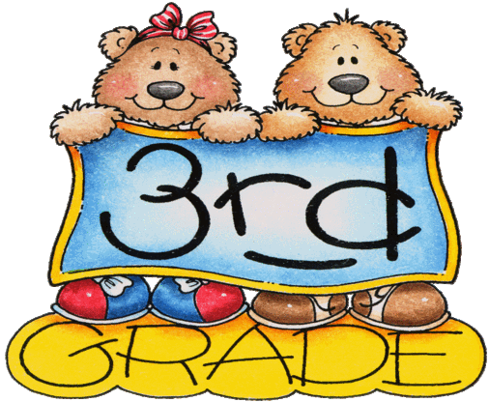

Welcome to 3rd grade!
In order to get the year off to a good start, I would like you to “Bag” yourself. Get a small paper bag or small grocery bag and fill it with about 6-8 things that tell something about YOU! Here are some suggestions:
*something in your favorite color
*the wrapper from your favorite snack
*the best book you’ve read
*something you collect
*something that tells about your favorite sport
Use your imagination to come up with 6-8 different items small enough to fit into the bag. (Hint: you can use a picture of a soccer ball instead of the real thing. But limit pictures to 2-3). We will be sharing these during the first days of school, so don’t wait until the last minute!
The night before the first day of 3rd grade, put your special bag with your other supplies you will be bringing to school. This way you will be sure to remember it!
I am looking forward to seeing you August 31st. Have a wonderful rest of your summer!
Mrs. Frarie

